Installing and configuring virtual machines

By Mohamed Firas Faisal

# Contents

**Contents 2**

**Introduction 3**

**Important Terminology 4**

Virtualization: 4

Virtual Machine: 4

Hypervisors: 4

**Installation of virtual machine 5**

**Creation of Virtual Machine 9**

**Windows setup 16**

**References 19**

# Introduction

This is a booklet on the topic of “virtual machines”. We will be looking at what some of the important terms mean, the installation and configuration of the virtual machine (We will be using the “ Oracle VM Virtual Box” for this installation) and installing some of the applications on a virtual machine.

# Important Terminology

### Virtualization:

Virtualization is a process that allows for more efficient utilization of physical computer hardware and is the foundation of cloud computing.Virtualization uses software to create an abstraction layer over computer hardware that allows the hardware elements of a single computer—processors, memory, storage and more—to be divided into multiple virtual computers. (“What is Virtualization?”)

### Virtual Machine:

A Virtual Machine (VM) is a compute resource that uses software instead of a physical computer to run programs and deploy apps. One or more virtual “guest” machines run on a physical “host” machine. Each virtual machine runs its own operating system and functions separately from the other VMs, even when they are all running on the same host. This means that, for example, a virtual MacOS virtual machine can run on a physical PC. (“What is a Virtual Machine?”)

### Hypervisors:

A hypervisor, also known as a virtual machine monitor or VMM, is software that creates and runs virtual machines (VMs). A hypervisor allows one host computer to support multiple guest VMs by virtually sharing its resources, such as memory and processing (“What is a Hypervisor?”)

ISO image

An ISO file (often called an ISO image), is an archive file that contains an identical copy (or image) of data found on an optical disc, like a CD or DVD. They are often used for backing up optical discs, or for distributing large file sets that are intended to be burned to an optical disc. (“What Is An ISO File”)

# Installation of virtual machine

In this booklet we will be looking at the installation procedure and configuration of the “Oracle VM Virtual Box”

First go to the virtual box website. 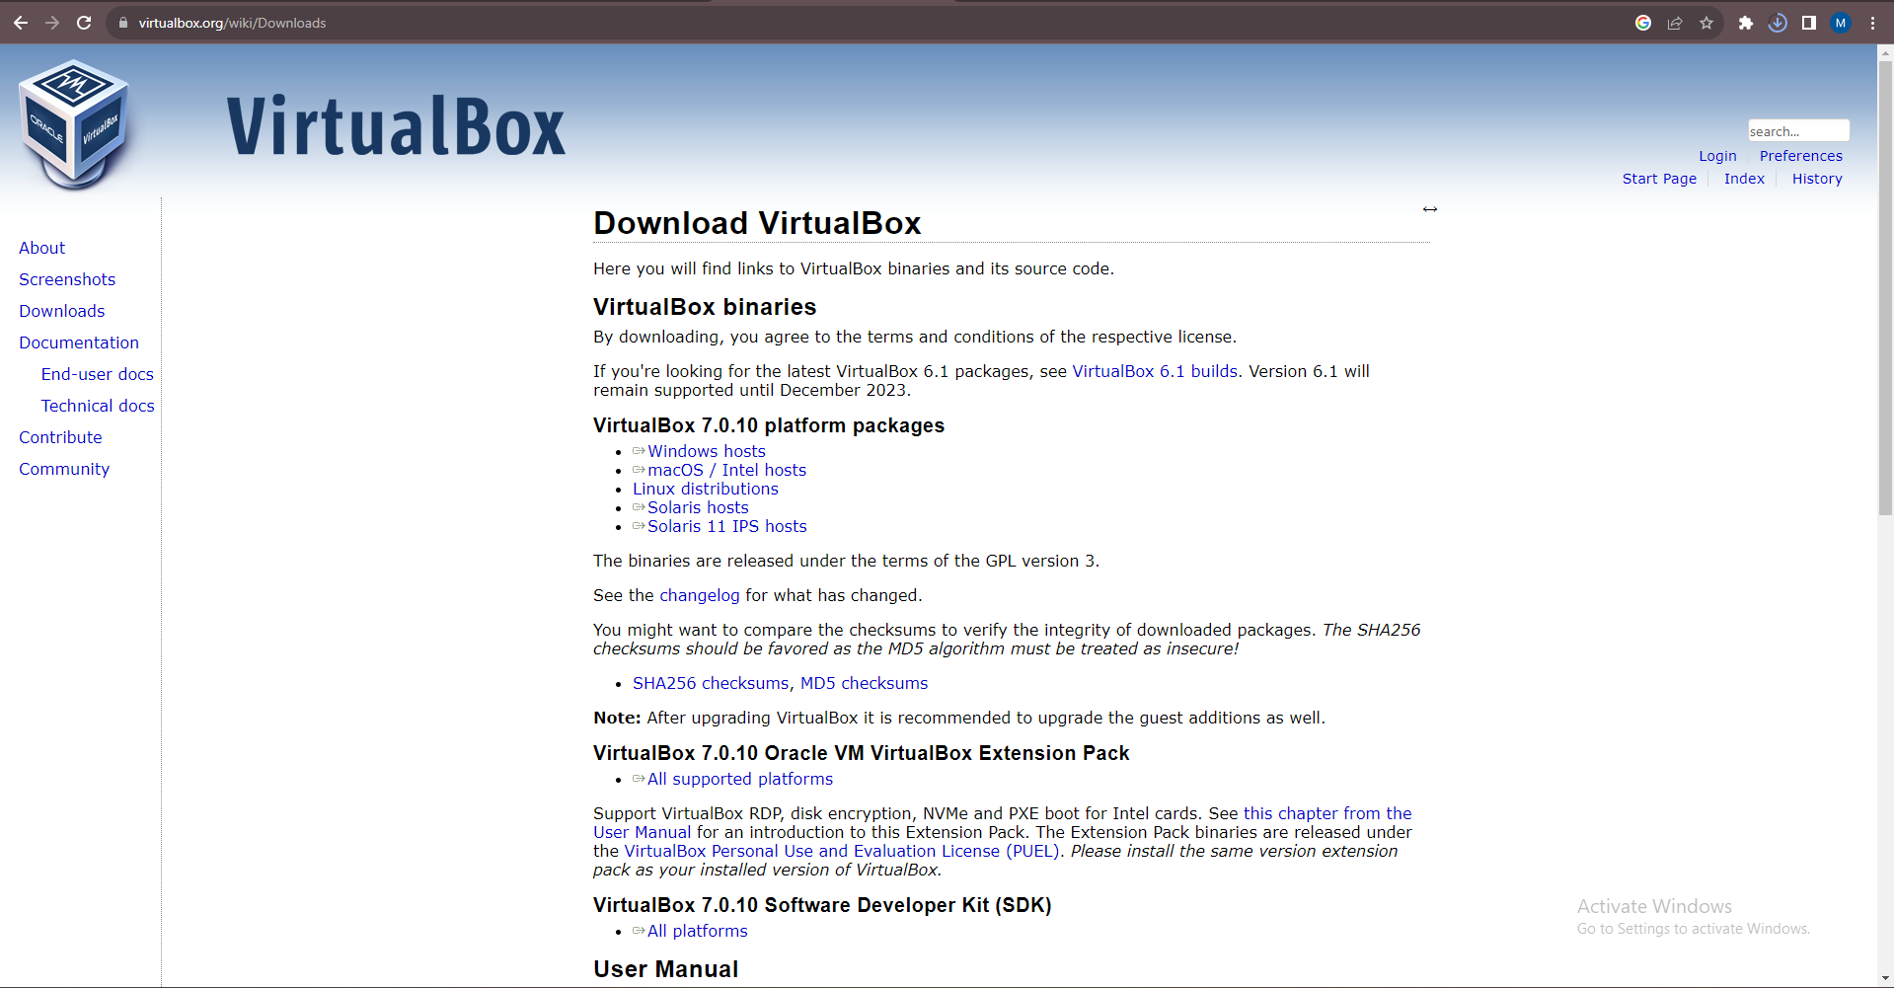

Install the version of virtual box for your Operating System.

When downloaded open the installer: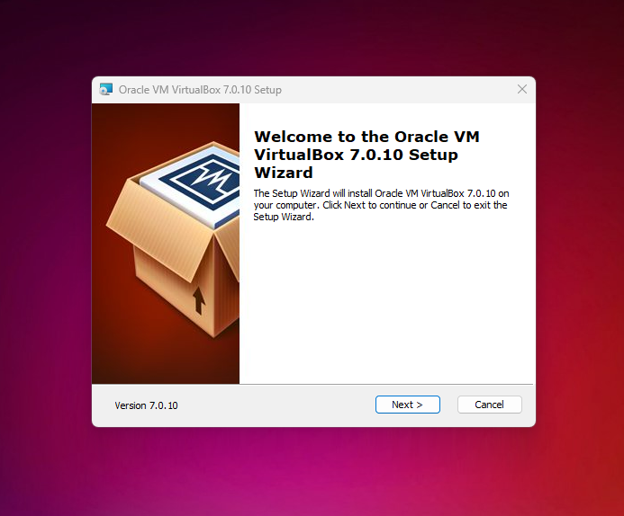

Click next.

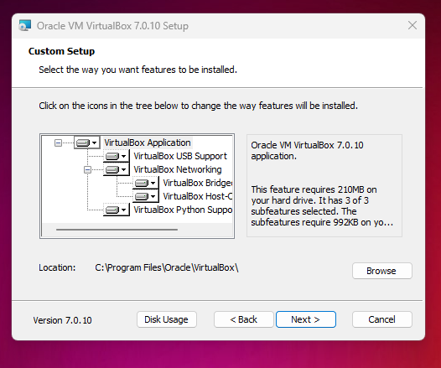

Click next.

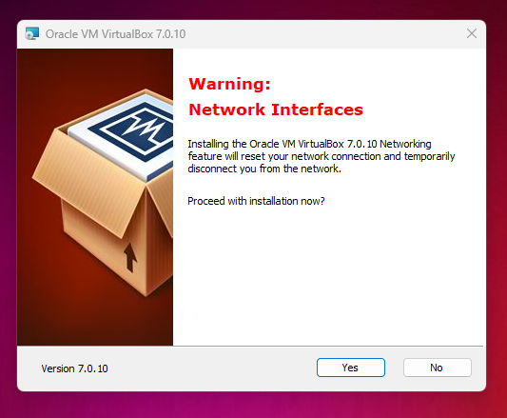

Click on yes ( you might experience slight network connection issues but it will not last long)

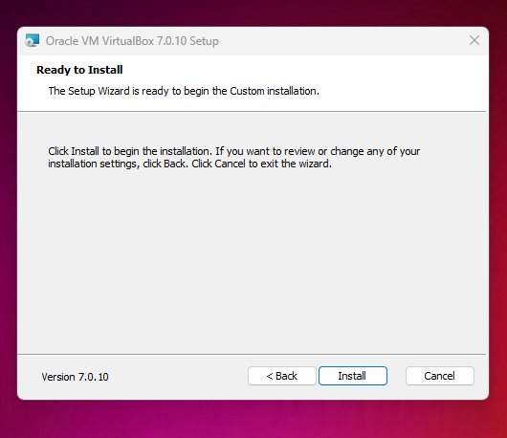

Press install

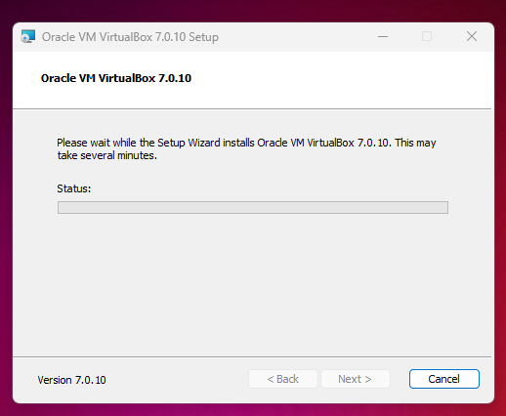

Wait until installation is finished.

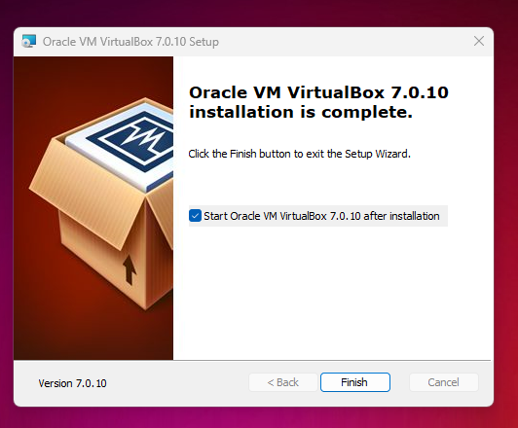

Press finish

# Creation of Virtual Machine

Now that you have successfully Installed Oracle VM virtual box (essentially the hypervisor) it is time to create a virtual machine.

Before we create one install an ISO image of the operating system you wold like to install (we are using windows 10 here)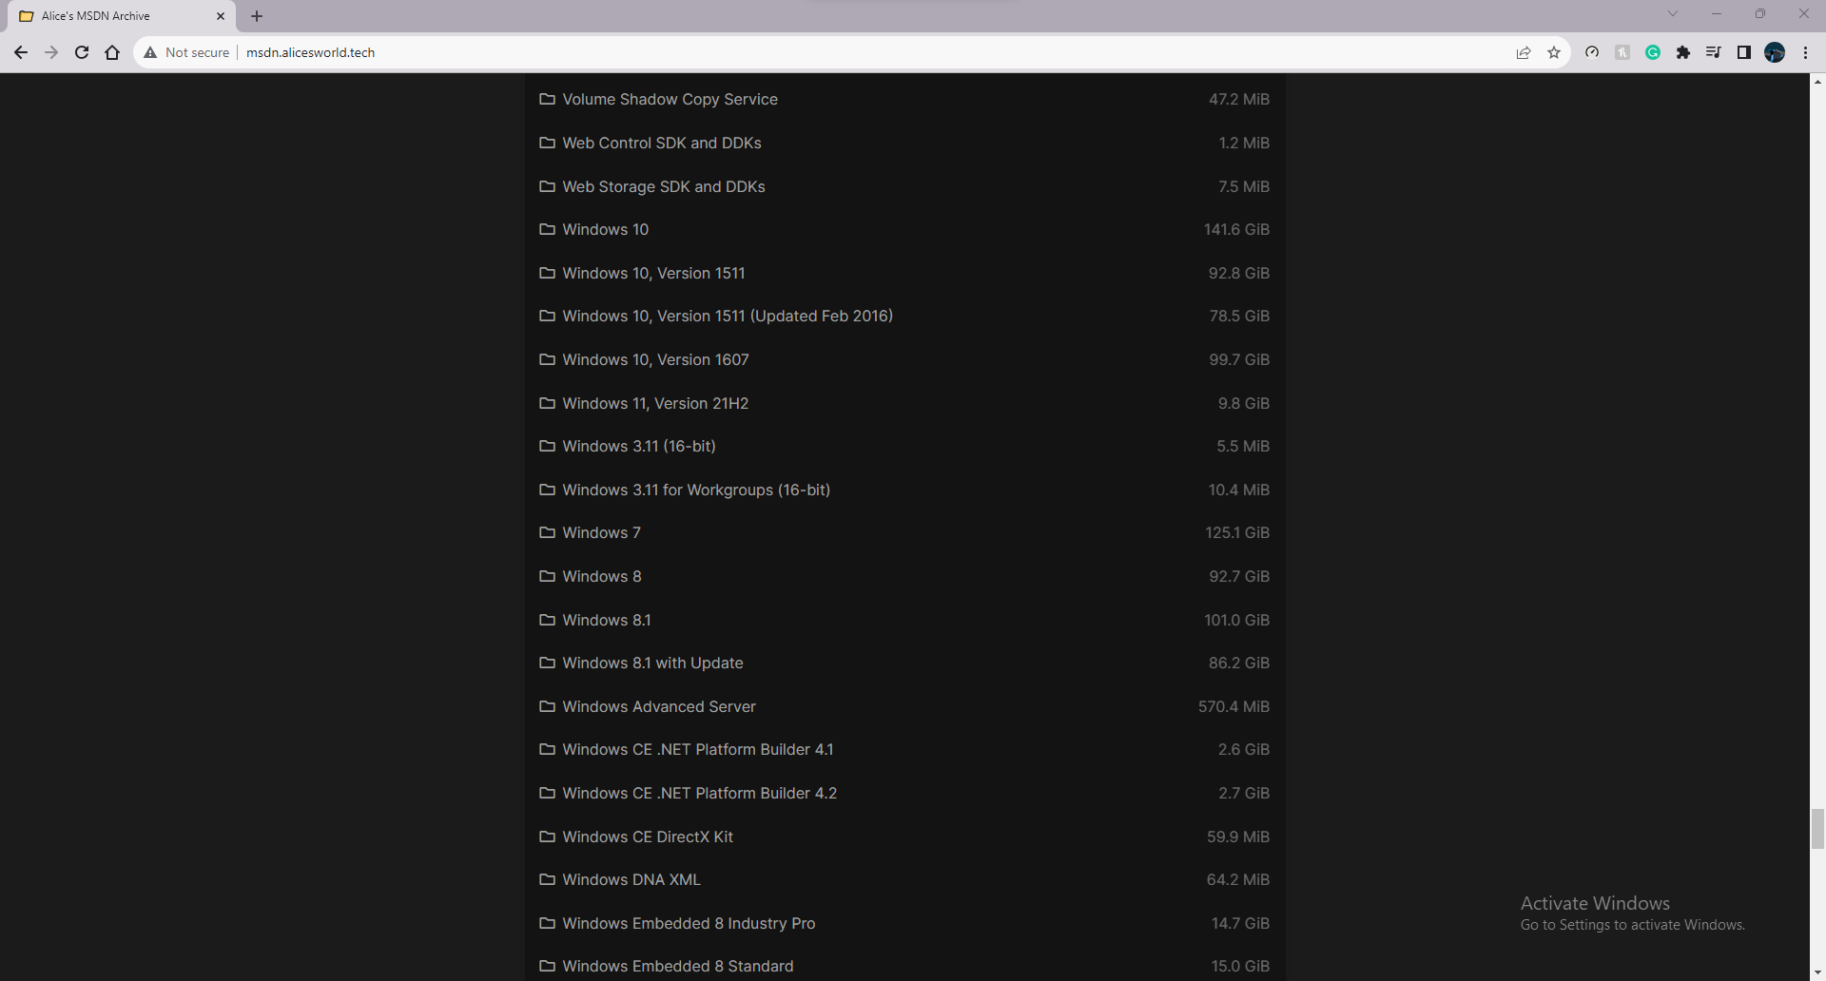

(“Alices MSDN Archive”)

Here we used a website called Alice’s MSDN archive

Scroll down and find the Desired Operating system and install it

First open the virtual box

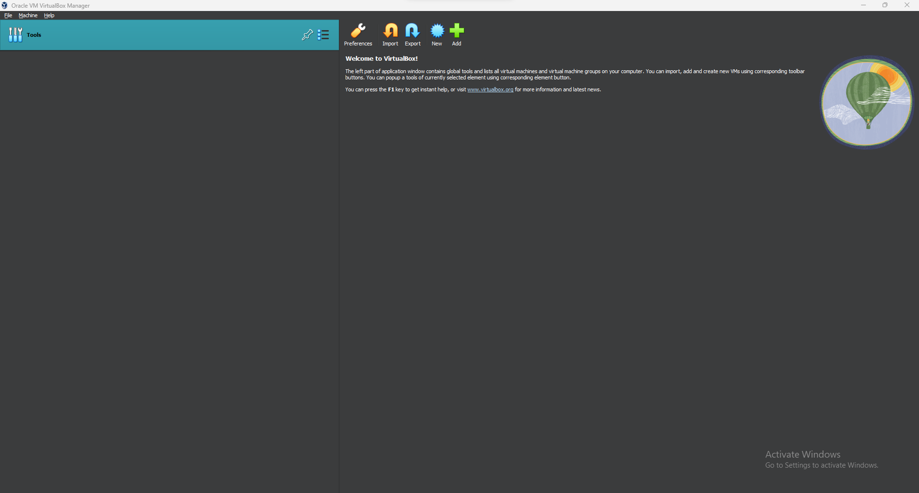

Press on new

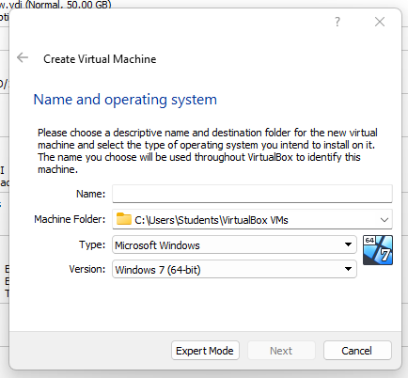

Give your virtual box a name and select the type of OS you will be using

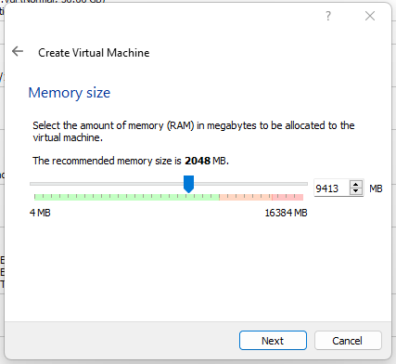

Select a memory size (preferably in the green zone)

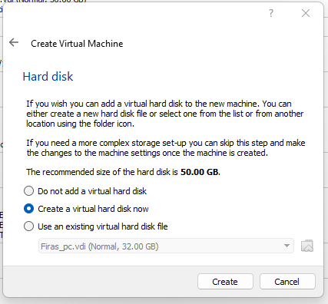

Create a virtual hard disk

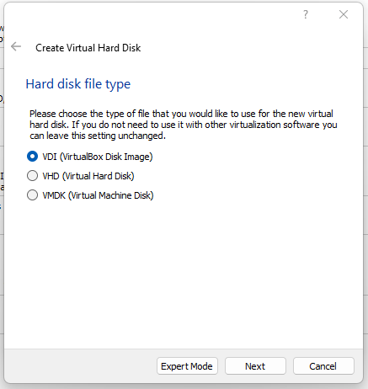

Go with the VDI option

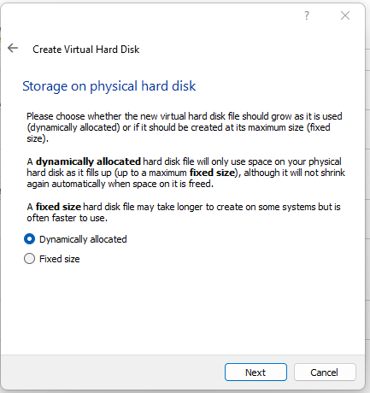

Select dynamically allocated

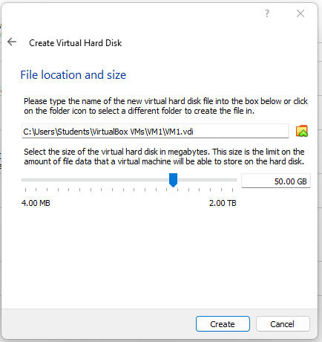

Select the amount of storage you want and hit create.

When you have created your virtual machine go to Its settings, and go to storage

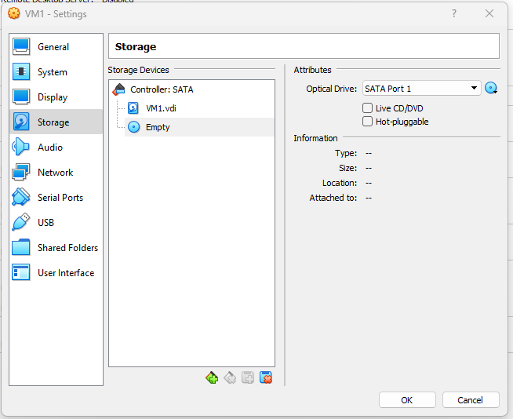

Click the little green plus at the bottom

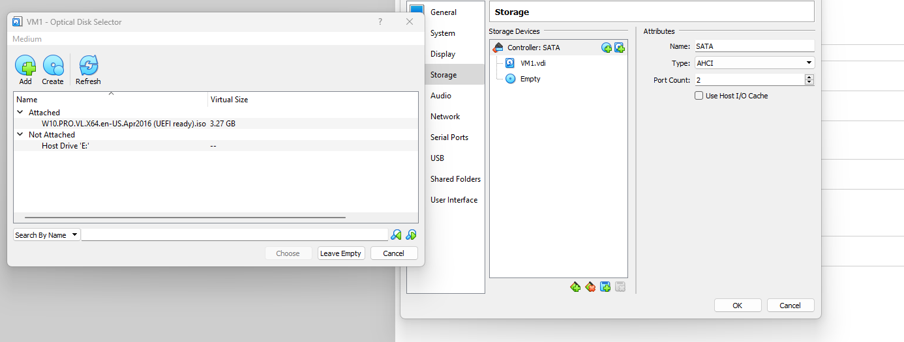

Then go and select the ISO image you have downloaded previously.

Hit OK and you are ready to set up your OS in your virtual machine.

You can modify all of the storage, and memory settings even after you create the virtual machine with the help of settings.

### 

### 

# Windows setup

Once you open the virtual machine you will be prompted to setup the OS (in this case Windows 10)

Just follow the instructions in the setup guide

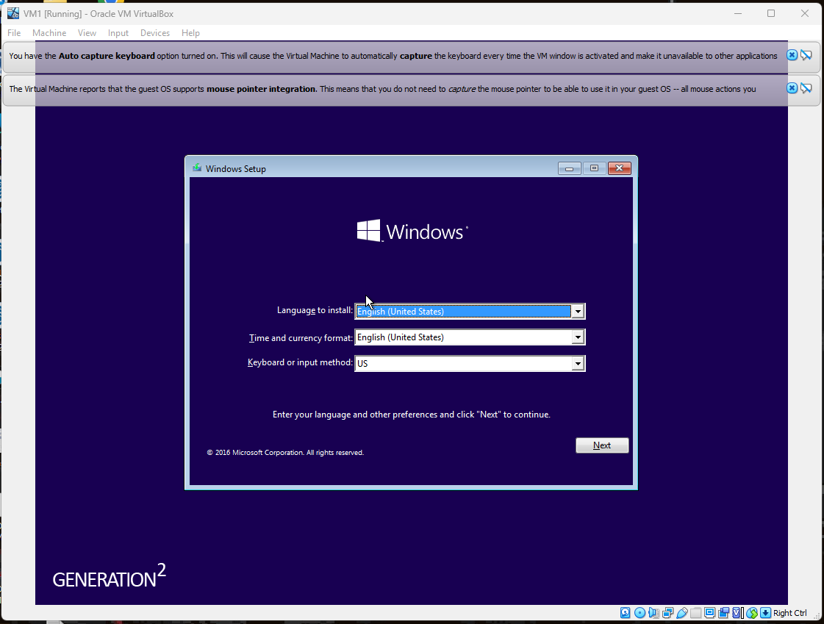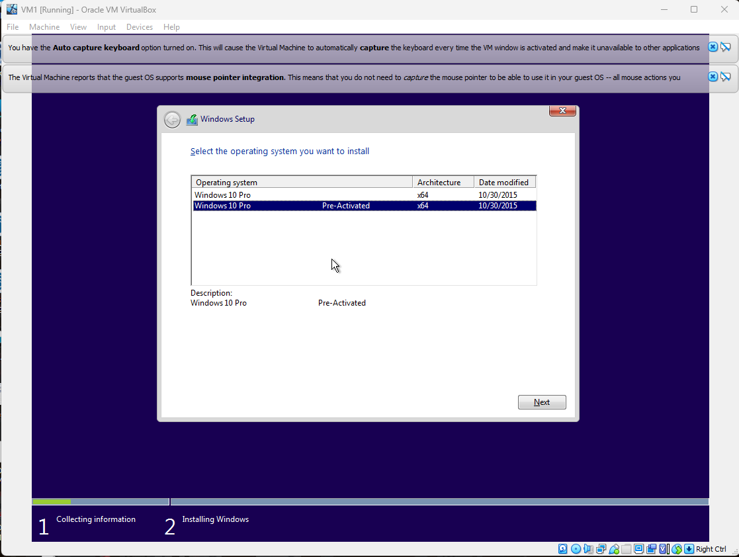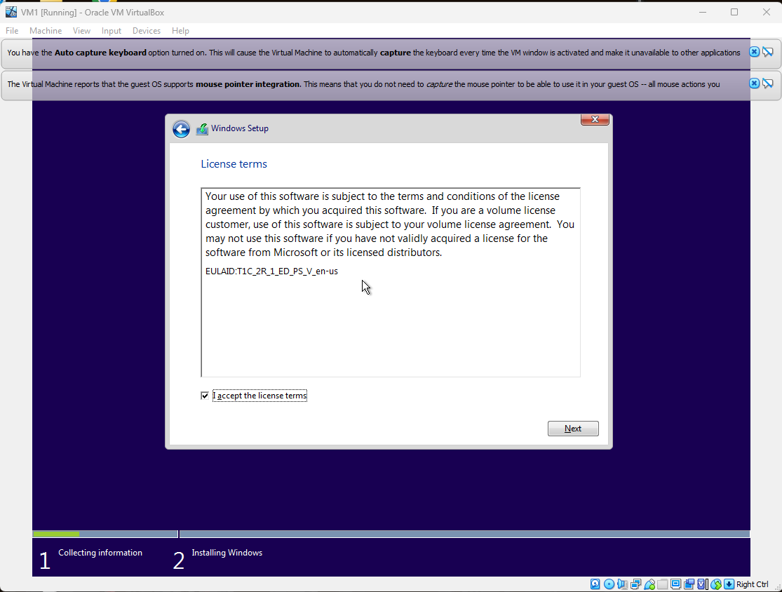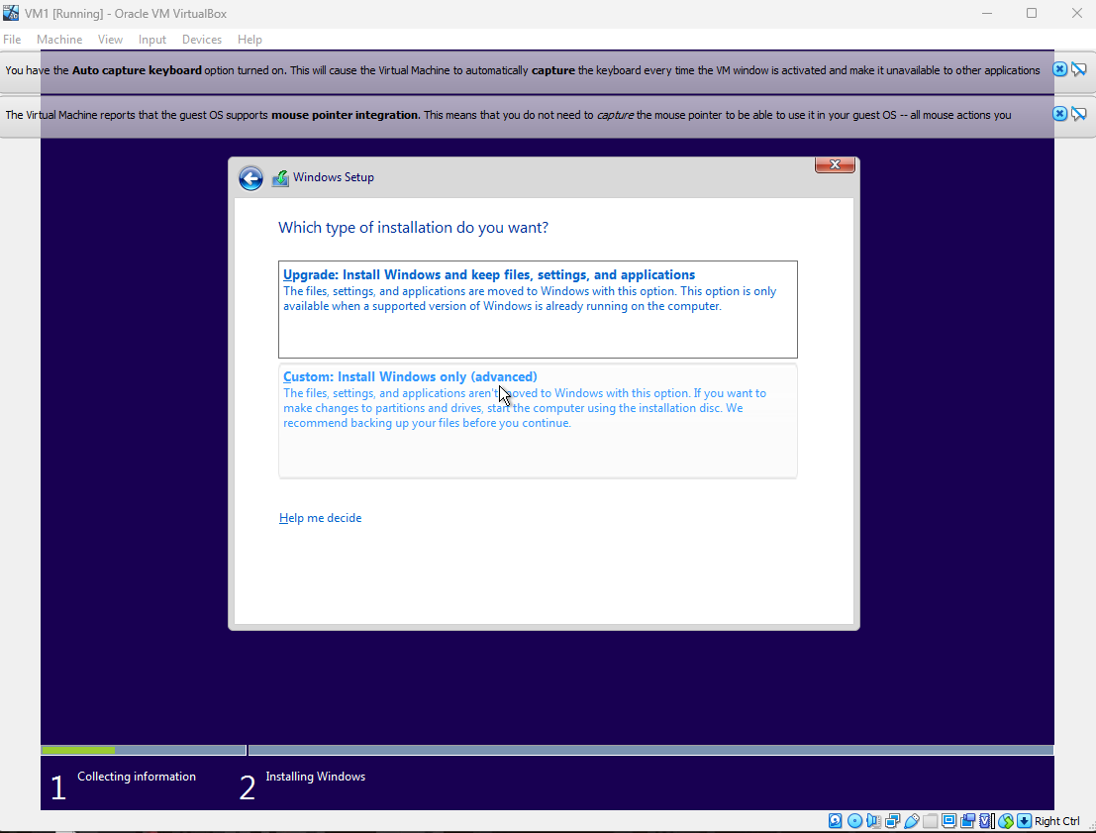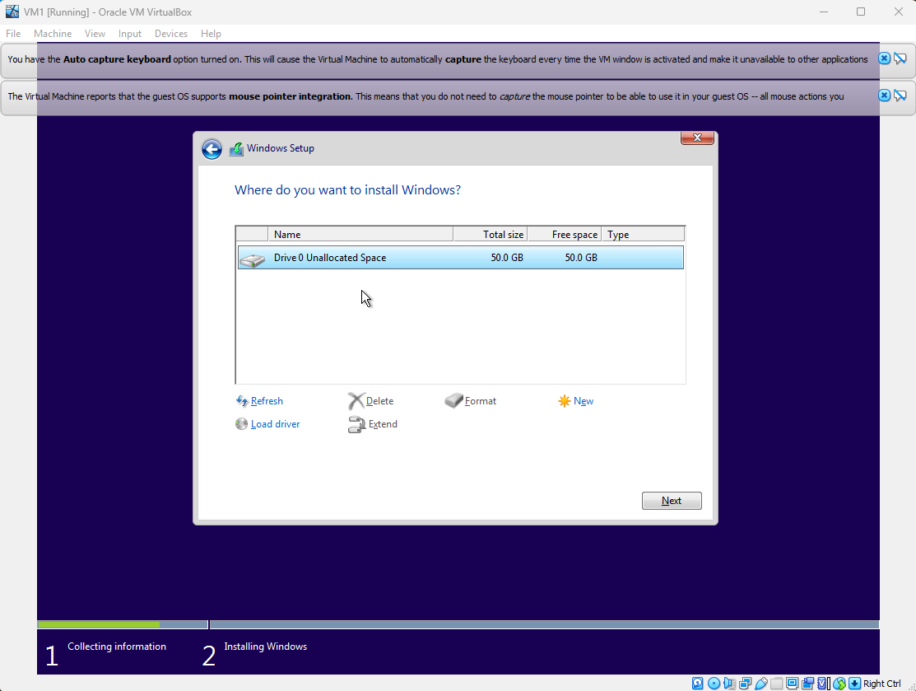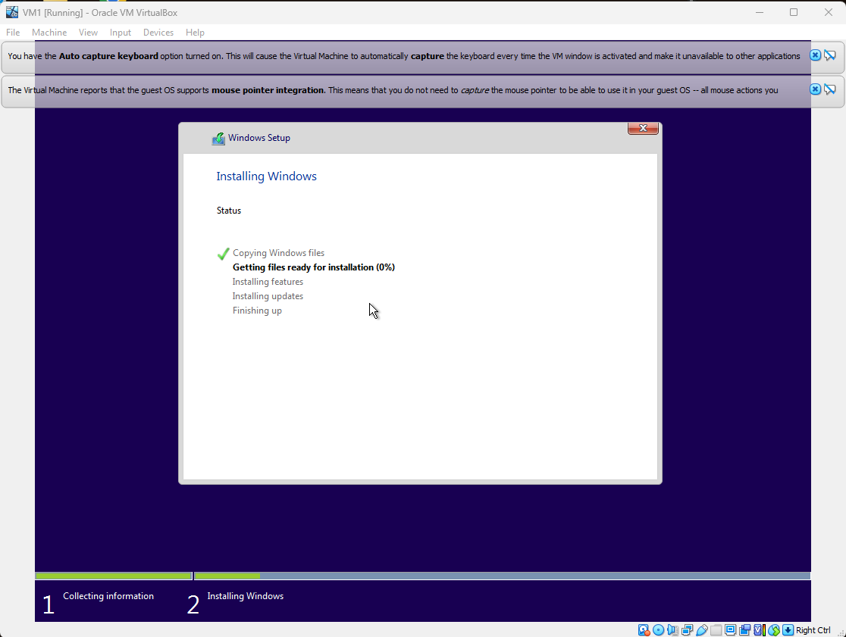

You can install applications with an ISO file. Go to settings and storage then add the .ISO file to it

# References

“Alices MSDN Archive.” *Alice's MSDN Archive*, https://msdn.alicesworld.tech/. Accessed 25 November 2023.

“What is a Hypervisor?” *VMware*, https://www.vmware.com/topics/glossary/content/hypervisor.html. Accessed 25 November 2023.

“What Is An ISO File.” *HowToGeek*, 10 August 2023, https://www.howtogeek.com/356714/what-is-an-iso-file-and-how-do-i-open-one/. Accessed 25 November 2023.

“What is a Virtual Machine?” *VMware*, Broadcom, https://www.vmware.com/topics/glossary/content/virtual-machine.html. Accessed 25 November 2023.

“What is Virtualization?” *IBM*, https://www.ibm.com/topics/virtualization. Accessed 25 November 2023.